DBSync
WorkQueue
Detailed Design Document
Author:Kaliven Lee
Version:0.1
Date:04-11-11

Contents
1 Introduction 5
1.1 Purpose 5
1.2 Scope 5
1.3 Definitions, Acronyms, and Abbreviations 5
1.4 References 5
1.5 Overview 5
2 Architecture 7
2.1 Architectural Goals and Constraints 7
2.2 Use-Case View 7
2.2.1 Use-Case Stories 7
2.2.2 Use-Case Diagram 9
2.2.3 Use-Case Realization 10
2.3 System Environment [optional] 10
2.4 System Logical Structure 10
2.4.1 Overview 10
2.5 Issues and Considerations [optional] 11
3 System Design/Change Summary 13
4 Static Class View 14
5 System Sequence View 15
5.1 Sequence Diagram 15
5.1.1 Sequence Diagram of Start Service 15
5.1.2 Sequence Diagram of Asset State Change 16
5.1.3 Sequence Diagram of Asset Metadata change 17
5.2 Program Flow Chart [optional] 18
5.2.1 Work flow of synchronize 18
5.2.2 Work flow of IDS event call back 18
5.2.3 Work flow of saving hierarchy 20
5.2.4 work flow of the parent check for saving a folder to hierarchy 20
5.2.5 Work flow of saving complex asset 22
5.2.6 Work flow of saving metadata 23
5.2.7 Work flow of throwing operation to work queue 23
5.2.8 Work flow of mapping between ITV and Local DB 24
6 Configuration 25
7 Directory (Folder) & File Structure 26
8 Data Dictionary 27
8.1 Table Diagram 27
8.2 Table description 27
9 Technical Consideration [optional] 29

Revision History
Version | Revise Date | Owner | Notes
0.1 | 04-11-11 | Kaliven Lee | File Create
0.2 | 04-11-18 | Kaliven Lee | Add file cache for work queue

Introduction

Purpose
- DBSync shall keep the local DB of application of NVOD over ITV Synchronizing with the DB on ITV AM.
- When some events happened on ITV AM, DBSync will inform the Application Server to take some procedures by inserting the operation into the work queue in Local DB.

Scope
- DBSync only synchronizes the Local DB from Remote DB instead of synchronizing both sides. The Local Application server will deal with the synchronization from Local DB to Remote DB.
- DBSync only take the responsibility of throwing the work to work queue. How to deal with the work queue and remove it from work queue is the responsibility of Local Application Server.

Definitions, Acronyms, and Abbreviations
Local DB : Local DB of application Server
Remote DB : Remote DB on ITV AM generally is IDSDATA on AM

References
[R01] DB Synchronizer.doc
[R02] workqueue detail design.Doc by comet.ye

Overview
- For the sake of the stability, DBSync should be packed as SeaChange Service.
- Every time DBSync launches, DBSync should update Local DB by Remote DB. And it is time-consumed. So it should not affect the running of the application server. And the time should be cut as much as possible.
- DBSync should throw all events triggered by remote ITV server to work queue. And application server will pick up what it cares most to deal with and remove it from the work inform from work queue.
- DBSync provides some tools to debug the program such as clear the Local DB.

Architecture

Architectural Goals and Constraints
The AM of ITV System is based on the SeaChange IDS service. From the point of view of integrality of remote DB, DBSync should get the data from IDS instead of operating the Remote DB directly. And DBSync also can get the trigger events from the IDS instead of adding triggers into remote DB which will add the load of the remote DB.
From the point of view of the stability of the application, DBSync should be packed as a SeaChange Service. It reads configurations from register and can be started and stopped from the MMC of OS and SeaChange Service Manager.
Work queue is a table in the Local DB. For the sake of expansibility, DBSync should add all operation events in the table with time stamp so that the application can pick up and process the events which it care by its sequence. And Work queue also acts as the buffer between operating DB of DBSync and procedures of application server.
DBSync will operate the Local DB through ODBC. Because ODBC access is a slow process, DBSync should reduce the access of DB as much as possible. But there still are many necessary accesses especially when service is launch. Typically the time will be up to 1 or 2 hours.
There are many work had been done before this doc. So DBSync must access DB though DBSync can throw the DB modification to work queue and let application to handle all the DB Access.

Use-Case View
This section lists use cases or scenarios from the use-case model if they represent some significant, central functionality of the final system, or if they have a large architectural coverage—they exercise many architectural elements or if they stress or illustrate a specific, delicate point of the architecture.

Use-Case Stories
Sea change Service behavior
Primary Actor: Service manager
Preconditions: IDS service is active. And Local DB had been build. Configuration is set correctly.
Success Guarantee: DBSync had been packed as SeaChange service correctly.
No. | Action | System Response
1 | Start Service from Service Manager | Start DBSync process.
2 | Stop Service from Service Manager | Stop DBSync process
3 | Monitor runtime variables by manutil | Monitor configurations and other runtime parameters
Note:
The modification includes the change of clip, element, asset, folder, application and its metadata.

Fill in the Local DB with the data from Remote DB
Primary Actor: DBSync
Preconditions: IDS service is active. And Local DB had been build. Configuration is set correctly. DBSync Service start.
Success Guarantee: DBSync update blank Local DB with Remote DB correctly
No. | Action | System Response
1 | Start Service from Service Manager | Retrieve data from IDS service. Insert the data to Local DB and throw the operation to work queue

ITV AM modify an asset
Primary Actor: ITV AM
Preconditions: IDS service is active. And Local DB had been build. Configuration is set correctly. DBSync Service start.
Success Guarantee: DBSync sinks the message from IDS service and update the Local DB successfully.
No. | Action | System Response
1 | Modify the components of an asset by ITV AM | Duration of the asset change, the hierarchy of the asset changed. And such operation is thrown to work queue.
2 | Modify the metadata of an asset by ITV Am | The metadata of the asset changed and such operation is thrown to work queue.
Note:
Modify include insert, update and delete operation.
Modify other object such application, folder, element and clip, the system should have the same response

DBSync service restart
Primary Actor: MMC or Service Manager
Preconditions: IDS service is active. And Local DB had been build. Configuration is set correctly. DBSync Service stopped for a period of time.
Success Guarantee: DBSync update Local DB with Remote DB correctly
No. | Action | System Response
1 | Start Service from Service Manager | Retrieve data from IDS service. Compare with the records in Local DB, if any different, update Local DB and throw the operation to work queue. Delete the record that had not been in Remote DB.

Use-Case Diagram
- System Actors
Actors that use this system.
- Use-Case Diagram
According to the use-case scenario.

Use-Case Realization
This section illustrates how the software actually works by giving a few selected use-case (or scenario) realizations, and explains how the various design model elements contribute to their functionality.

System Environment [optional]
This section description the system’s context and its hierarchy structure, explain the relationship between the layers, define the system boundary.

System Logical Structure

Overview
From the point of view of service, DBSync Service is composite with Core and Service Shell. And Core should deal with the interaction between IDS service, Local DB and Work Queue.

IDS Service
Work Queue
Local DB
Application Server
Call back
DB interface
IDS Sinker
DBSync Core
Service Shell provides the function of SeaChange Service. It packs the core to be a SeaChange Service according the SeaChange Service protocol.
DBSync Core
Service Shell
MMC
SeaChange Service Manger
Operation System

Issues and Considerations [optional]
- In some cases, the status of object in Local DB can not be updated on time
Description:
When DBSync crashed for a period of time, Local DB will be different with Remote DB. So when DBSync restarts, it will update the Local DB with the data from IDS Service. And if Local DB has many records (usually typical user DB will be more than 2000 records), DBSync will spend long time (Usually it will take 1-2 hours) to synchronize the Local DB. During this period of time, Application that depends on the Local DB will not get the latest data. So some problems will be launched.
Example:
Such as, But because of the previous problem, an asset has been delete in ITV system but Local DB still has this record. From the application’s point of view, the asset can be play. So when user plays the asset there will be black in the screen.
Solution:
We can’t avoid of such problem, but we can reduce the affection of this problem. A solution is to reduce the time to synchronize the Local DB. We can optimize the code to reduce the access to DB to enhance the performance.
2. In some cases, there will be a difference between work queue and Local DB
Description:
Because it is a separated process for DBSync to update the Local DB and throw the operation to work queue, there will be a possibility that DBSync access work queue successful and updates Local DB failed. It means that application server will do the same behavior several times.
Example:
If DBSync service is running in different machine and the network breaks when DBSync finished writing to work queue and start operating Local DB, DBSync will failed to write to work queue and application server will not keep synchronizing with Remote DB.
Solution:
Write a failed log message. Sooner a log tool will be developed to monitor the log. And increase the global parameter gFailedWorkQueueCount. The variable is monitored by manutil so that administrator can know the error intuitionisticly. And when Application server read work queue it will get the old value and new value. Then, it verifies the LocalDB if there is change. If not, remove the record from work queue. Otherwise, make such change as work queue say.
3. filter list
Description:
In most of case, application server cares only the change of some MetaData. If DBSync thrown all the change to the workqueue, the load of DB will increase directly.
Example:
DBSync reads the MetaData name list application server care more from configuration file. Application main care the metadata of the folder ,asset and element. For the sake of the expansibility, DBSync uses initial file “filterlist.ini” as the configuration file.

System Design/Change Summary
This section provides a high overview of whole system design or the changes to be made.

Static Class View
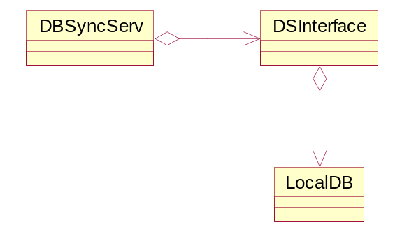
DBSyncServ SeaChange Service Shell derived class inherit from Class BaseSchangeServiceApplication .
DSInterface IDS Interface. Sink message from IDS and call LocalDB to update Local DB
LocalDB packed ODBC access API.

System Sequence View

Sequence Diagram

Sequence Diagram of Start Service
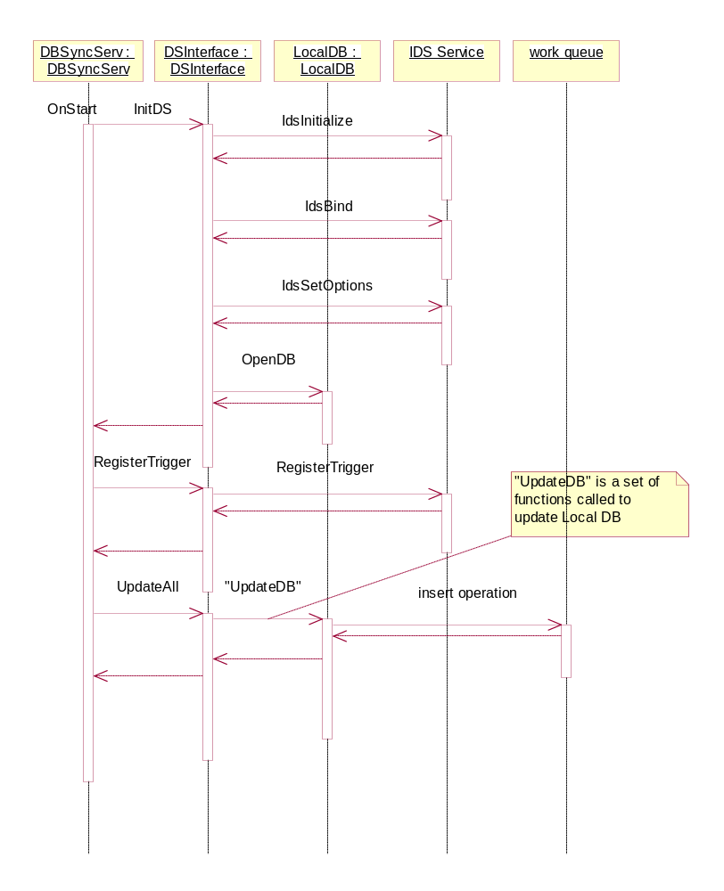

Sequence Diagram of Asset State Change
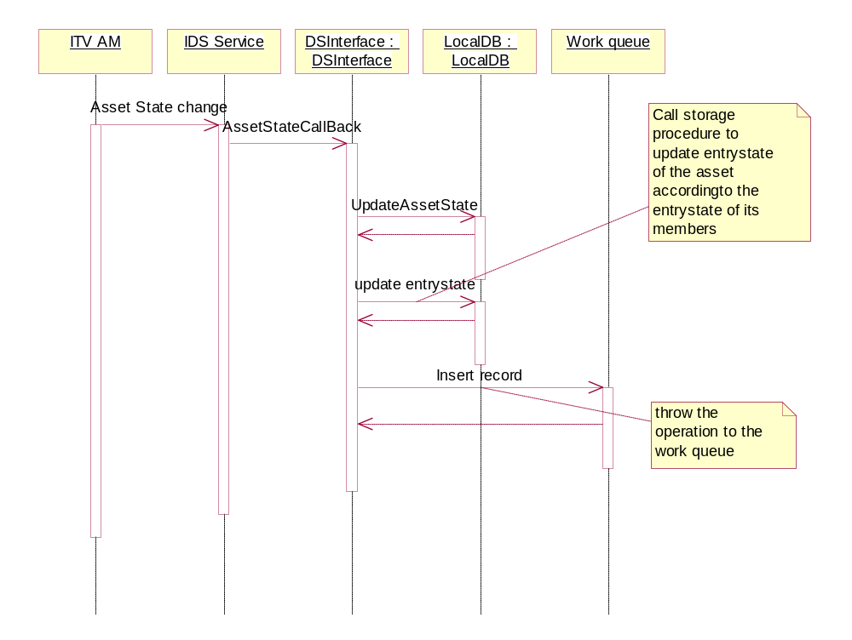
DBSync can sink the state change of asset and element. The diagram describes a general sequence of asset. And element state change will follow this sequence.

Sequence Diagram of Asset Metadata change
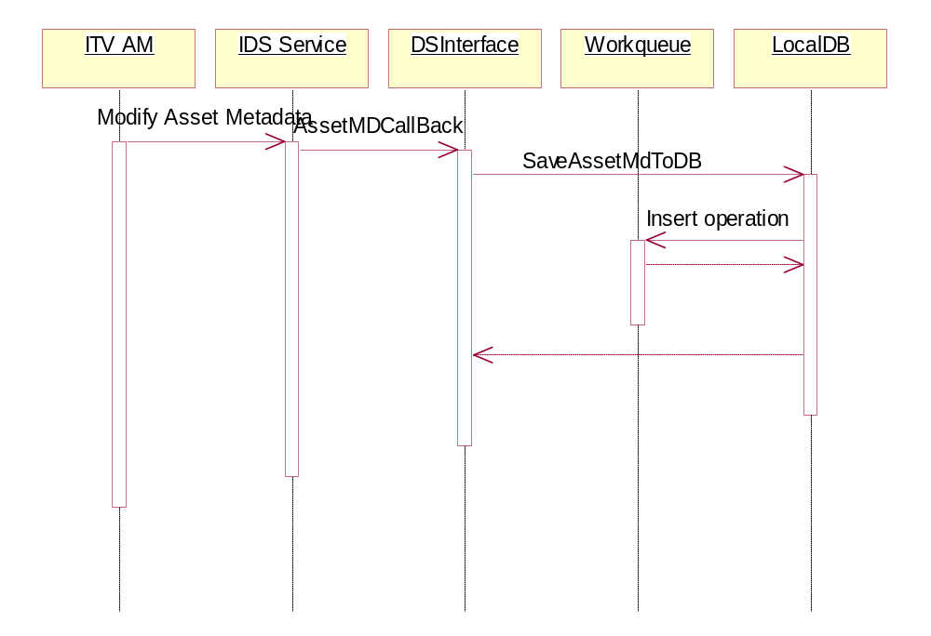
DBSync can sink the changes of the metadata of ITV object such as clip ,element, asset ,folder ,application and site. DBSync can get the operation and the new data of the metadata. DBSync updates, deletes or inserts the data to Local DB according the operation. And then insert the operation to Local DB. And the metadata of other object follow the sequence of as asset.

Program Flow Chart [optional]

Work flow of synchronize
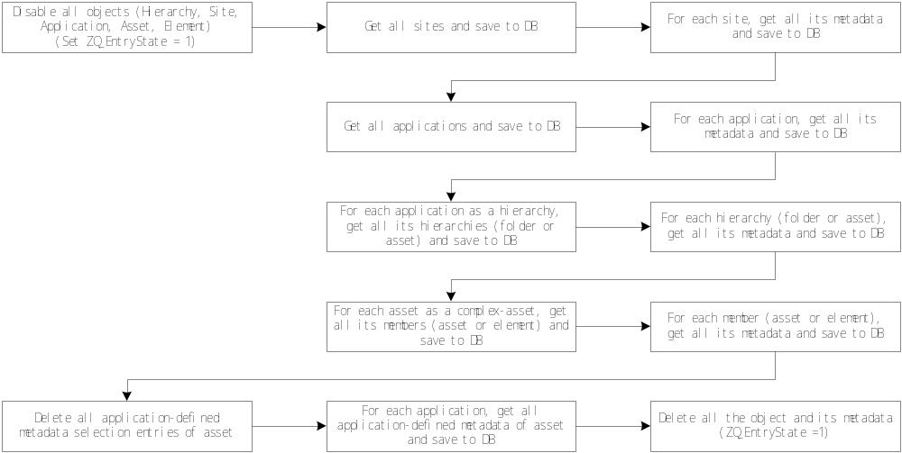
When synchronizing, DBSync get the data from the IDS service. But it does not know which record had been deleted in ITV before DBSync launched. So it set the ZQ_EntryState to 1 to set it under updating. If any record had been updated, set it’s ZQ_EntryState to 0 to active it. And after all the process close, the records whose ZQ_EntryState is still 1 are the record had been deleted before DBSync launched.

Work flow of IDS event call back
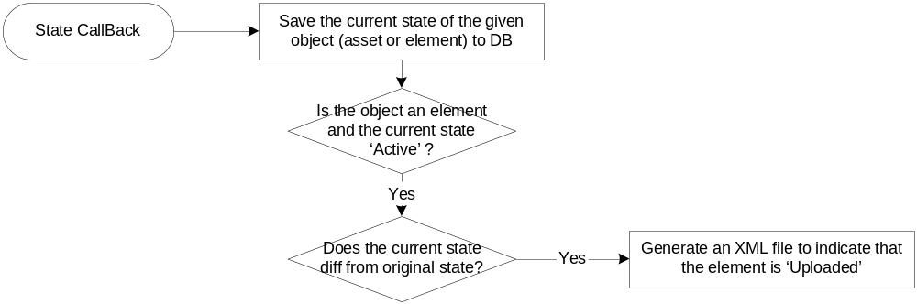
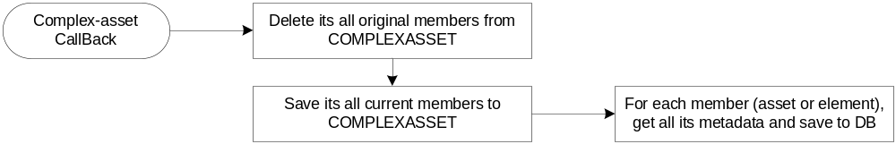
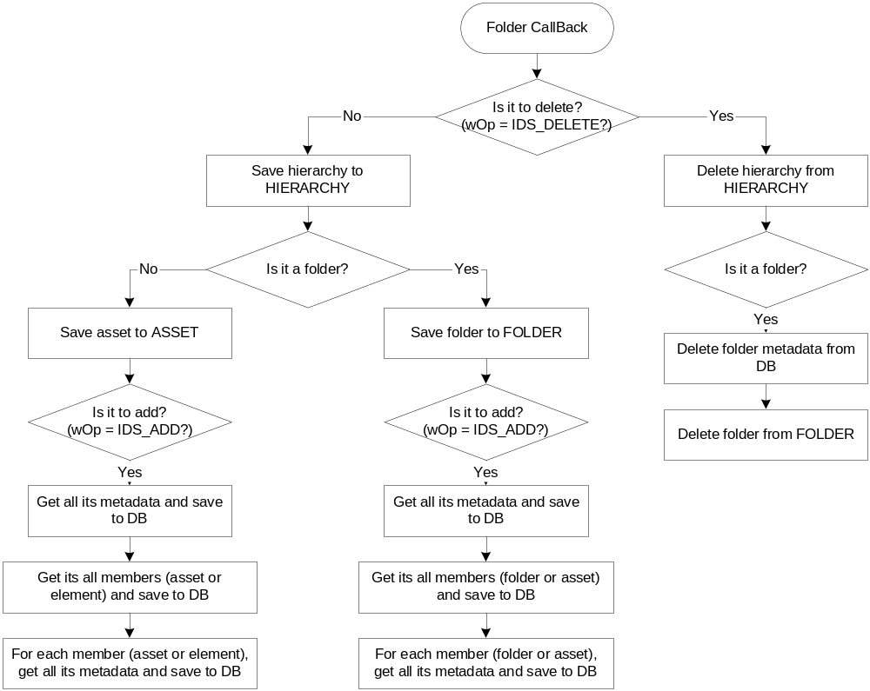

Work flow of saving hierarchy
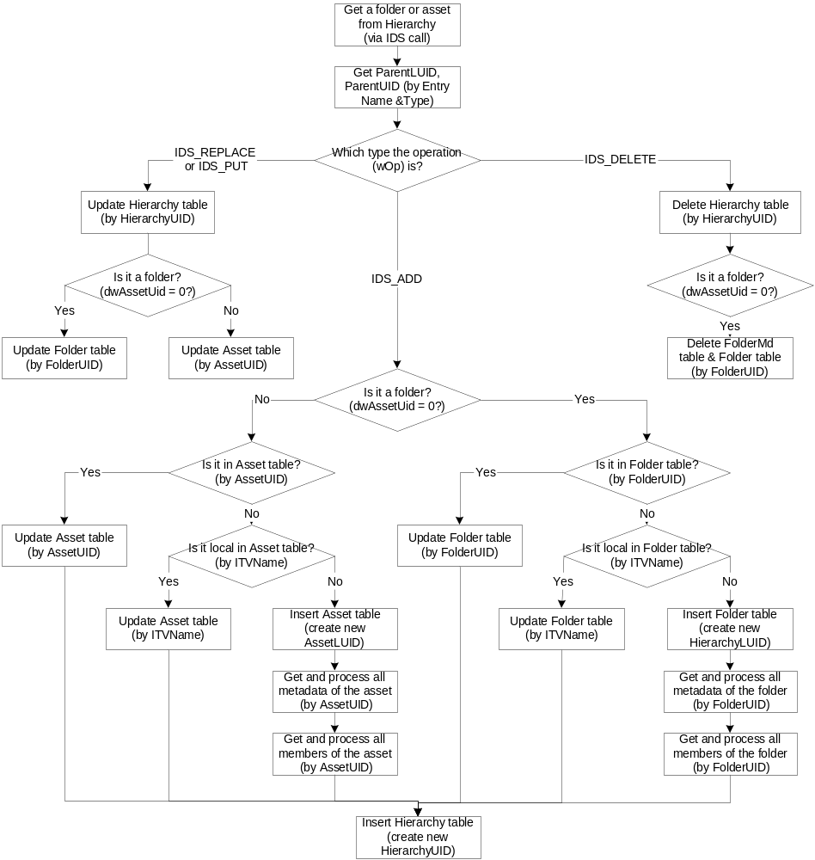

work flow of the parent check for saving a folder to hierarchy
Because folder can hierarchy from folder and application, but DBSync can not ensure the type of a folder. So there will be a conflict between application and folder with the same UID. So when query parent from table hierarchy, there will be two records returned. So DBSync must query all the children of the “parents” to see which one is the real parent of the folder. It is the work flow of the parent check.
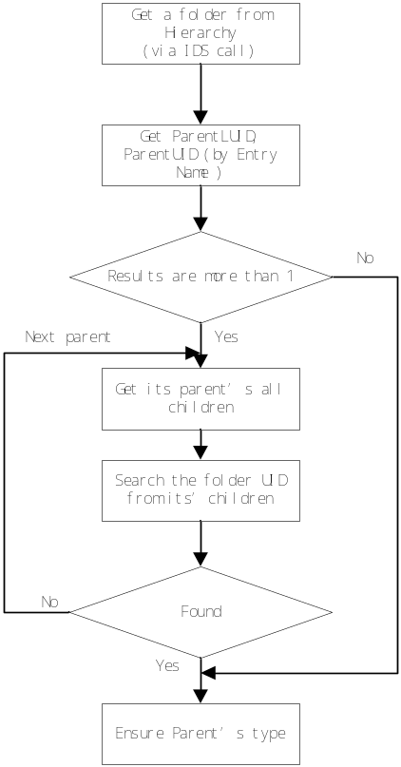

Work flow of saving complex asset
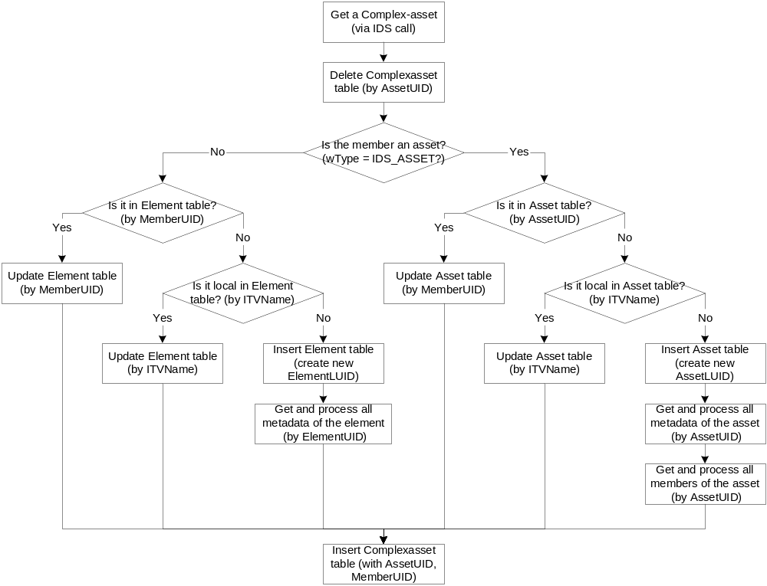

Work flow of saving metadata
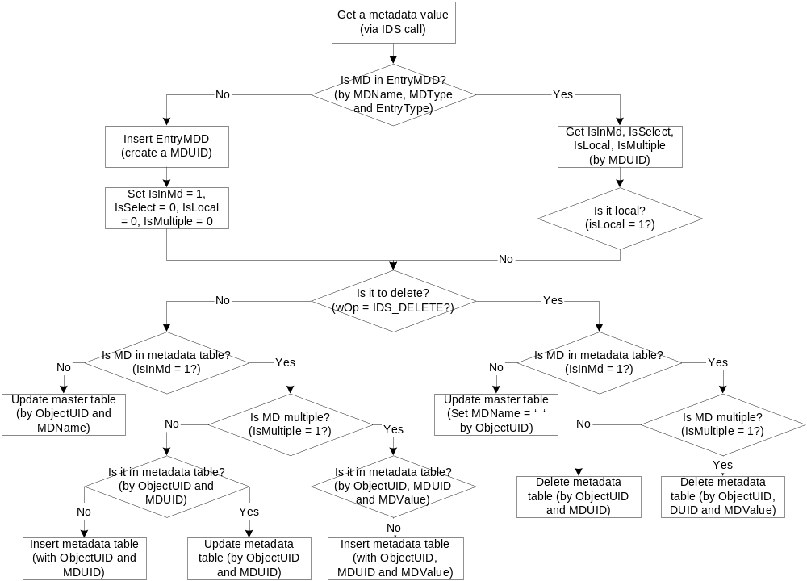

Work flow of save record to Local DB
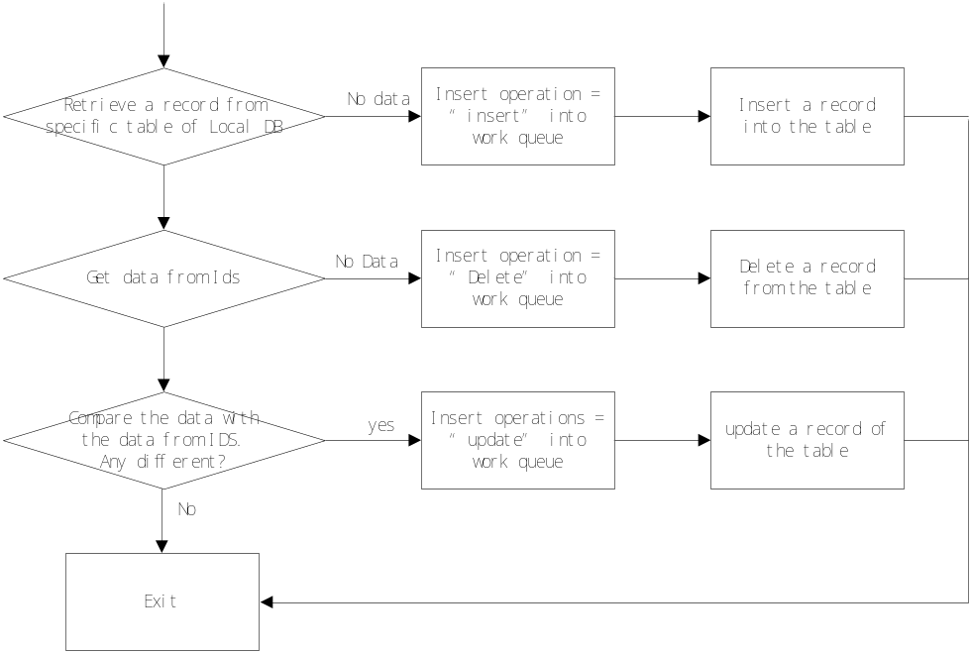
For the sake of reducing the access of DB, DBSync should read all the values of related record from Local DB. And then DBSync compare it with the data from the IDS service. If any different, throw the modification to work queue and update the Local DB.

Work flow of mapping between ITV and Local DB
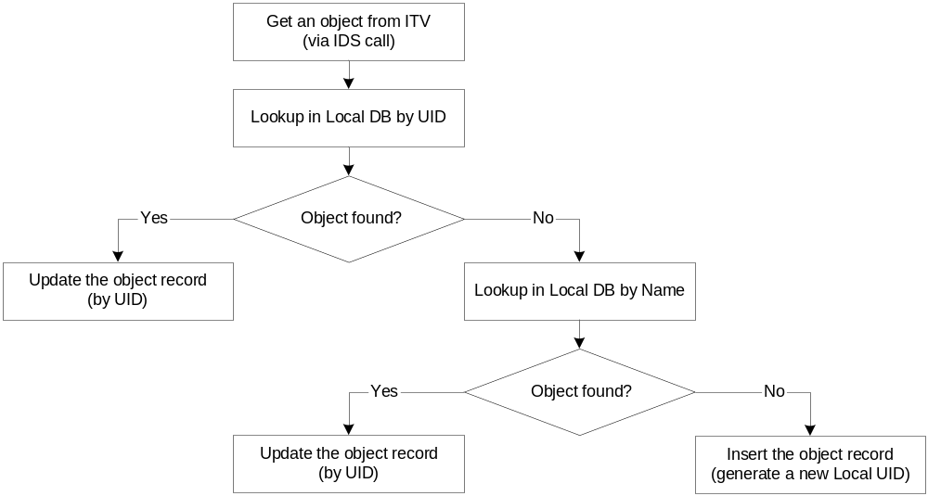

Configuration
DBSync read Configuration from OS register.
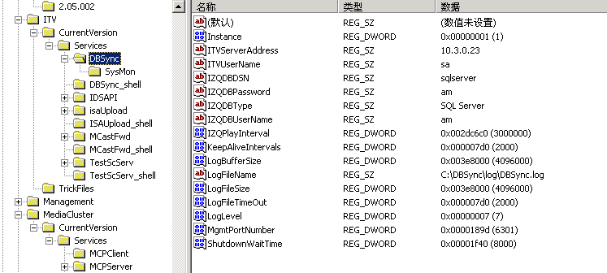
Installshield will set default value of the DBSync automatically.
HKEY_LOCALMACHINE\Software\Seachange\ITV\CurrentVersion\Services\
Configuration | Content | Default value
ITVServerAddress | IDS server Address | 10.3.0.23
ITVUserName | IDS Server user Name | sa
IZQDBDSN | ODBC DSN of Local DB | sqlserver
IZQDBPassword | Local DB Password | am
IZQDBTYPE | Local DB type(SQL Server or Oracle) | SQL Server
IZQDBUserName | Local DB UserName | am
IZQPlayInterval | Local DB play interval | 3000000
LogLevel | 0(ERROR)-7(DEBUG) | 7
CacheFileName | Cache file name and path | C:\DBSync\exe\filecache.dat
Initial file: filterList.ini
[METADATA]
Folder = xxx;xxx;xxx
Asset = xxxx;xxxx;xxxx
Element = xxx;xxx;xxx
The metadata is separated by semicolon . when DBSync initialized it reads the list into memory. Any if any change happens, DBSync must be restarted to retrieve the list.

Directory (Folder) & File Structure
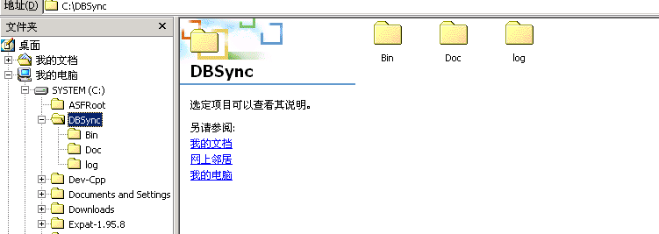
Installshield will install DBSync automatically. The default Directory is C:\DBSync.
Directory | Content
DBSync\Doc | Storage document for DBSync
DBSync\Log | Storage document for DBSync(default)
DBSync\Bin | Storage binary files

Data Dictionary

Table Diagram

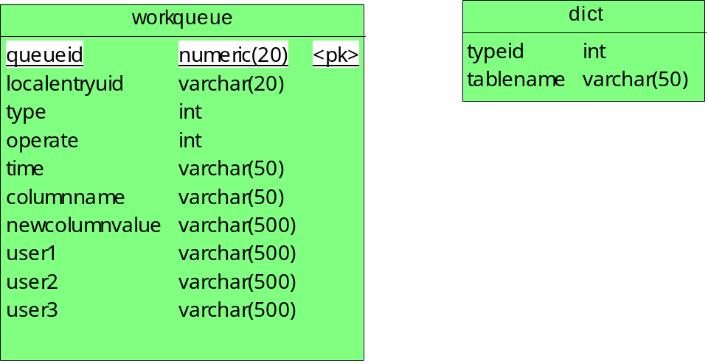

Table description
Workqueue table: save the data that modified in AM or ITV
Queueid: the queue id that is the primary key in the table
Localentryuid: the local entry id that represent LocalAssetUID, LocalAtomicElementUID, LocalFolderUID and so on.
Type : the changed object type ,the type corresponding table is defined in dict table
asset(1)—asset table
asset metadata(2) –assetMD table
element(3) –atomicelement table
element metadata(4)—atomicelementMD table
folder(5)—folder table
folder metadata(6)—folderMD table

operate : what action happen in the object
insert(1) – insert operate
update(2) – update operate
delete(3) – delete operate
time : the operate time
columnname : the modified column name ,if the table is metadata ,the column name is MUID
newcolumnvalue : the modified value if the table is metadata ,the newcolumnvalue is MUValue
User1, user2, user3 column save the user define data, such as description

Technical Consideration [optional]
Some errors handle do not be discuss in this document and were left to be done in the future.
- Write work queue failed
Description:
Write Local DB success and fail to write work queue.
Possible solution:
DBSync retry the network until the work queue can be written. Before that, write a file to cache all the operation should be thrown to work queue. If the work queue is all right, throw the operation in cache to work queue.
- IDS failed
Description:
There is not any fail-over handling in IDS service call. And moreover, if IDS service is crashed and restarted, DBSync will not get the registered call back from IDS.
Possible solution:
Restart DBSync manually?

